A&A CORVETTE PERFORMANCE SINGLE PUMP FUEL SYSTEM
INSTALLATION INSTRUCTIONS LATE 2003 TO PRESENT MODELS

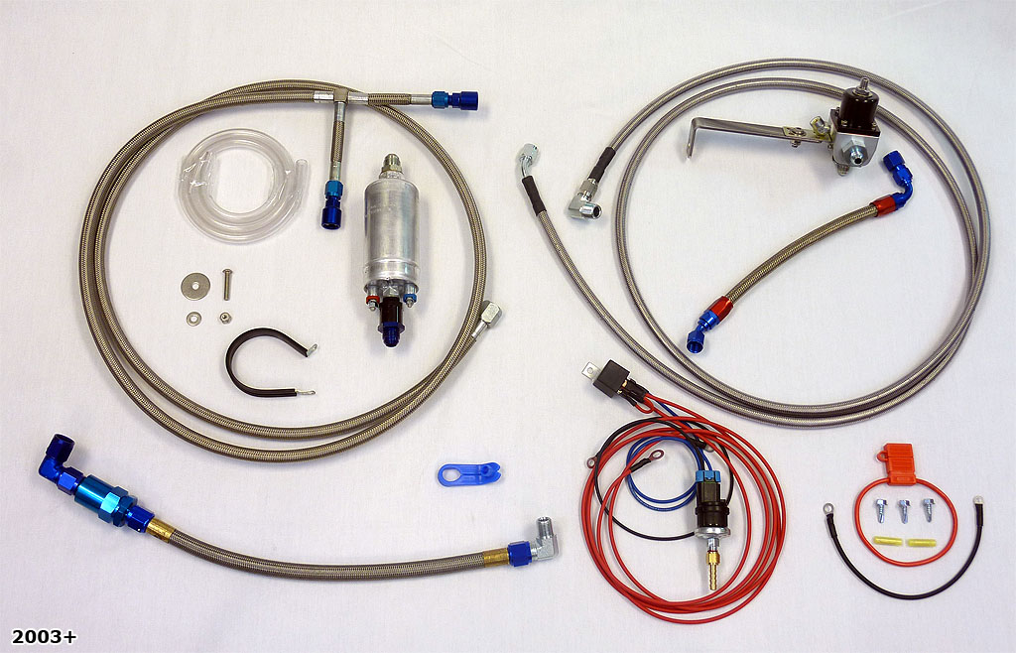

- GETTING STARTED
Proper installation of this fuel system requires general automotive mechanic knowledge and experience. Please browse through each step of this instruction manual prior to beginning the installation to determine if you should refer the job to a professional installer/technician. Follow all safety precautions needed for handling gasoline. Please contact A&A Corvette if you need assistance.

  - The gas tank will need to be drained as low as possible. Raise the car on a suitable lift or jack stands. Relieve the fuel pressure by depressing the Schrader valve on the end of the driver’s side fuel rail. Catch the escaping fuel in an appropriate container.

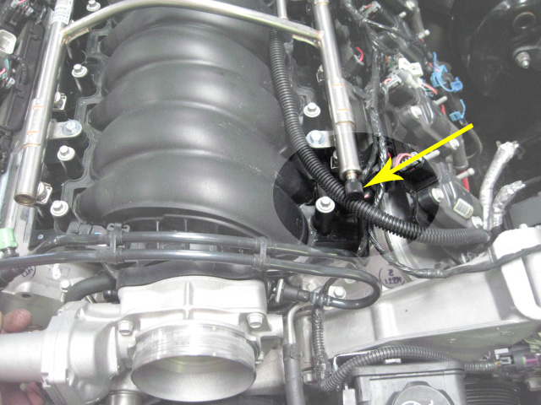
(SCHRADER VALVE)

- Using the supplied quick disconnect tool, remove the braided fuel line that runs from the hard factory fuel line to the fuel rail. Catch the escaping fuel in an appropriate container.

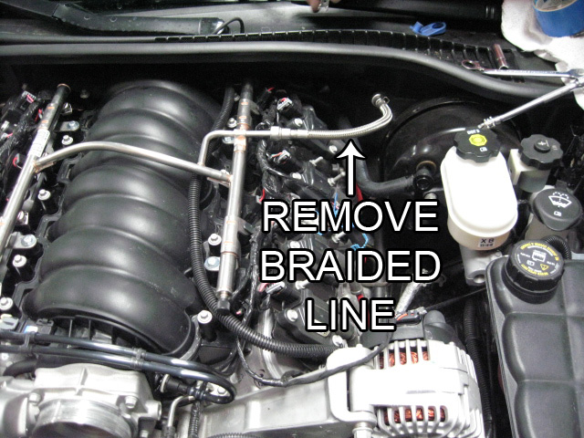
(REMOVE BRAIDED LINE)

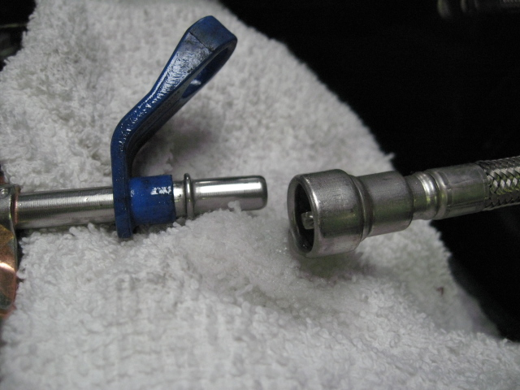
(SUPPLIED QUICK DISCONNECT TOOL)

1.3 Attach the supplied clear hose to the factory hard line and route the other end into a large gas can or similar container. Remove the fuel pump relay from the fuse box located in the engine compartment. Check your owner’s manual to verify the correct location for the relay. Insert a jumper wire into the fuse box terminals as shown. This will run the fuel pump and drain the tank into the gas can. Continue to drain the tank until no more fuel flows. Disconnect the battery when the draining is completed.

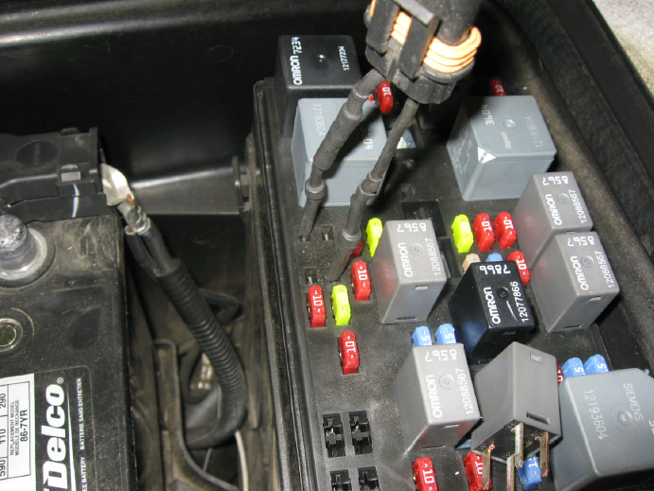
(JUMPER WIRES INSERTED)

- FUEL LINES
  - Remove the rear driver side wheel. Remove the aluminum tray that holds the tank in place. The tank will only drop 1-2 inches when the tray is removed. Remove the inner left rear wheel liner.

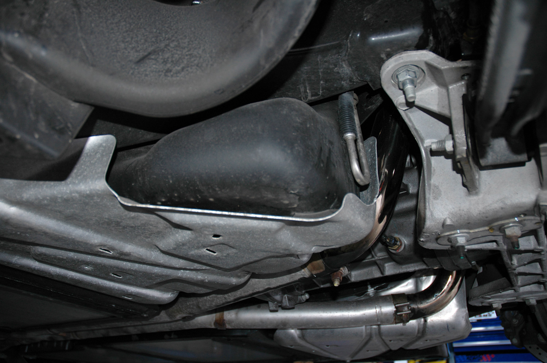
(DRIVER SIDE FUEL TANK TRAY - LATE 2003 AND NEWER MODELS)

2.2 Locate the pump, 90 degree union, fuel filter and 15” -8 AN hose. Loosely attach these pieces as shown and put the assembly in the left fender well. The line should follow the contour of the tank and end up at the rear of the tank.

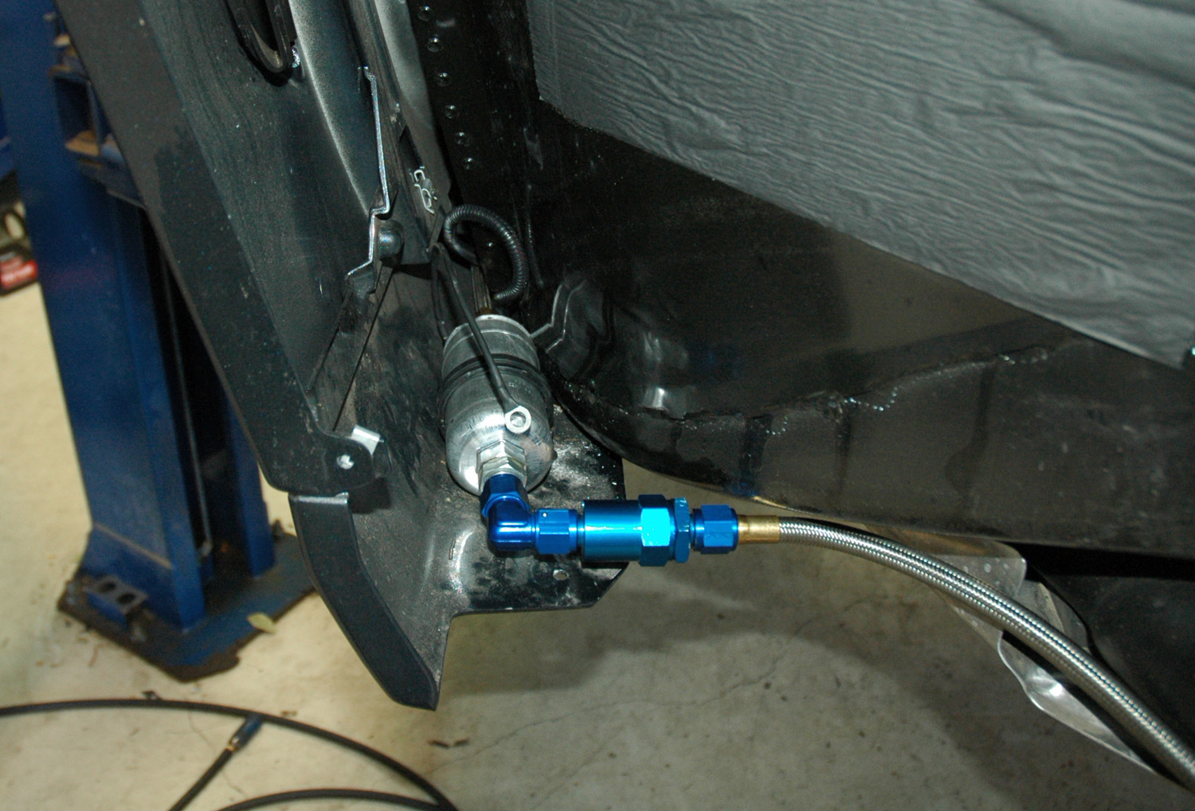
(PUMP MOUNTED IN LEFT FENDER WELL)

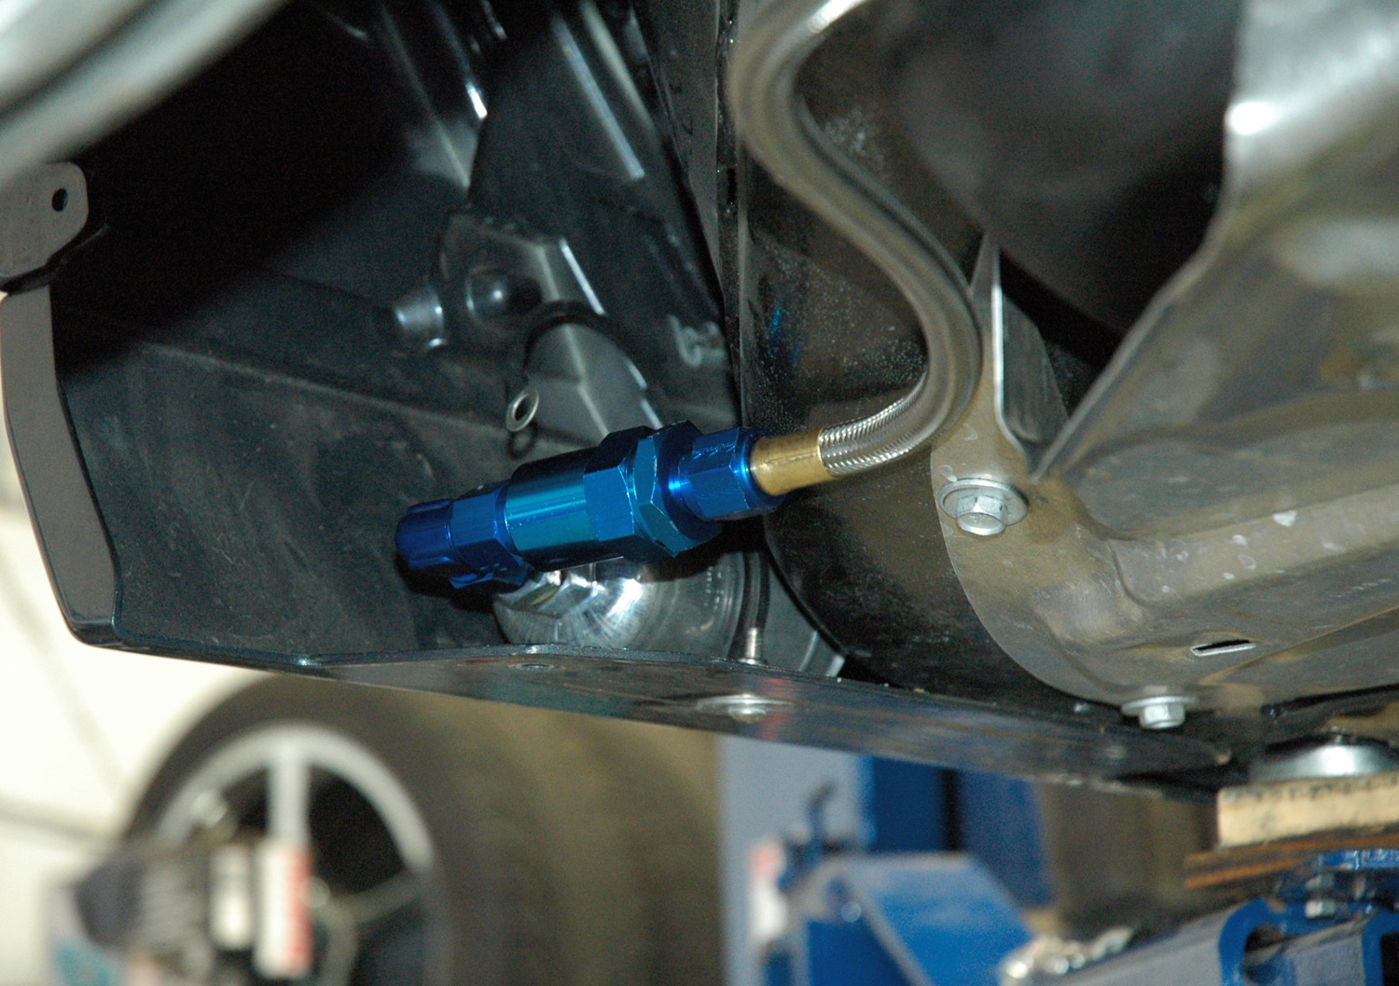
(FEED LINE FOLLOWING CONTOUR OF TANK)

2.3 The 15” line should line up with the rear surface of the tank. Locate the spot where the 90 degree end will meet the tank with the line following the frame contours and mark it. Make sure the spot is as low as possible on the back of the tank. Remove the pump assembly for now. You will be drilling a hole in the tank at this spot. The fitting is a tapered thread and will tighten up as it is screwed in. Drill the hole with a 9/16” bit (Use an air powered drill. DO NOT use an electric or battery powered drill around fuel). Some fuel will come from the hole, so be prepared with a pan or container to catch it. Tap the hole with a 3/8 NPT tap. Tap just deep enough so that the fitting will start in the hole. This way the tapered thread will get extremely tight as the fitting goes into the hole. The tank is quite thick and made of a nylon sort of material. It will seal on the tapered thread as it goes in. Put some of the provided Gasoila sealer on the tapered fitting and install it in the hole. The end should face the driver’s side when finished. Attach the 15” braided line to the tank fitting and secure it at an upwards angle just to stop the dripping for the time being.

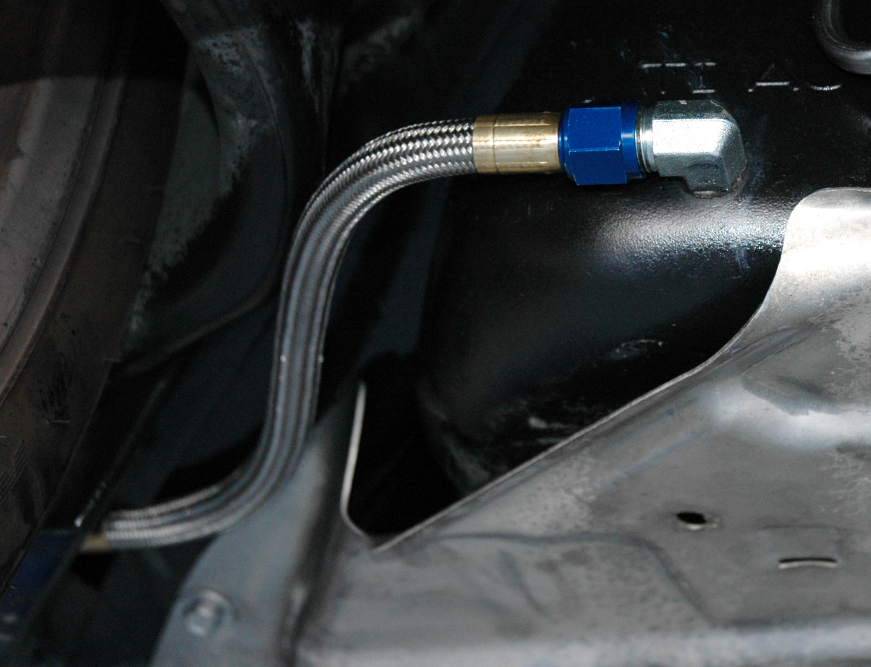
(FEED FITTING INSTALLED)

2.4 Remove the driver side front wheel. Remove the access panel behind the left front wheel. Locate the long braided fuel line, with the “T” on one end, and the fuel pump relay wire. Tape the end of the long red wire to the end of the fuel line. Tape the end of the fuel line so dirt won’t get into it. Push it through the rocker panel until it comes out the back side. Un-tape the wire and attach it to the positive terminal on the pump. Make sure the positive terminal is facing away from the frame. Attach the braided hose to the pump outlet and tighten. Find a suitable spot on the frame, clean some paint, and attach the ground wire. Drill a 3/8” hole through the bottom of the rocker panel where the pump attachment clamp is located. Insert the button head bolt from the bottom and tighten the pump assembly in place. Run the fuel line straight up and over the top of the brake booster/ master cylinder as shown. Click the “T” fuel line assembly onto the factory fuel line and fuel rail as shown.

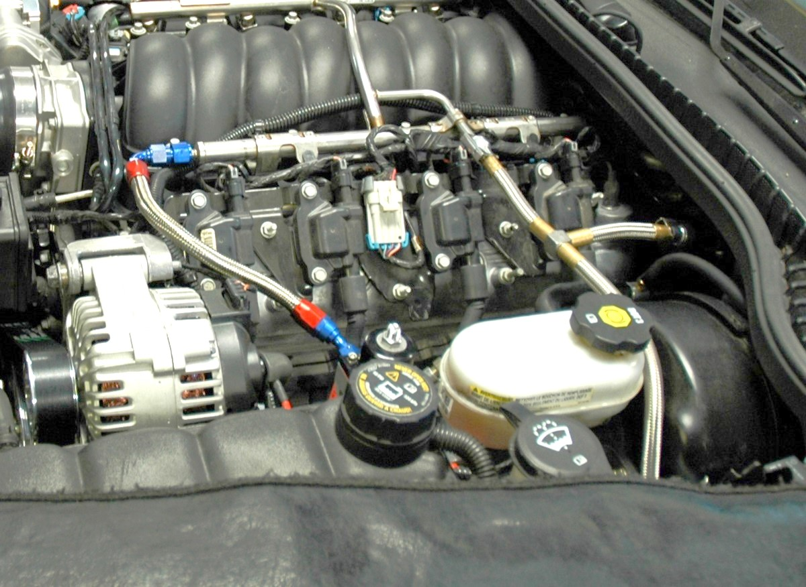

TFE BRAIDED FEED “T” FUEL LINE IN PLACE

2.5 Remove the nut attaching the master cylinder to the booster and attach the stainless bracket to the booster. Reinstall the nut and tighten. Remove the Schrader valve from the end of the fuel rail using a valve core removal tool or small blade screwdriver and install the adapter fitting on the rail end. Attach the 90 degree end of the braided return line to the fuel rail. Attach the short return line to the fitting on the side of the regulator.

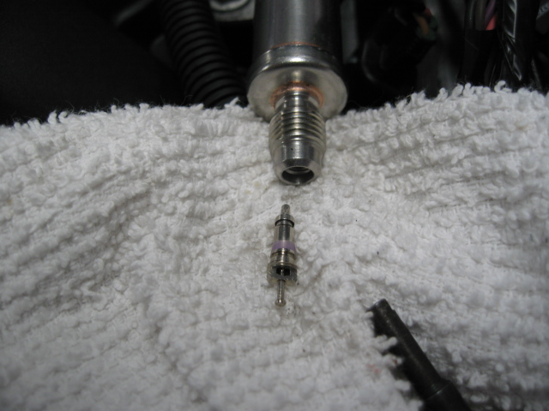
(SCHRADER VALVE CORE REMOVED)
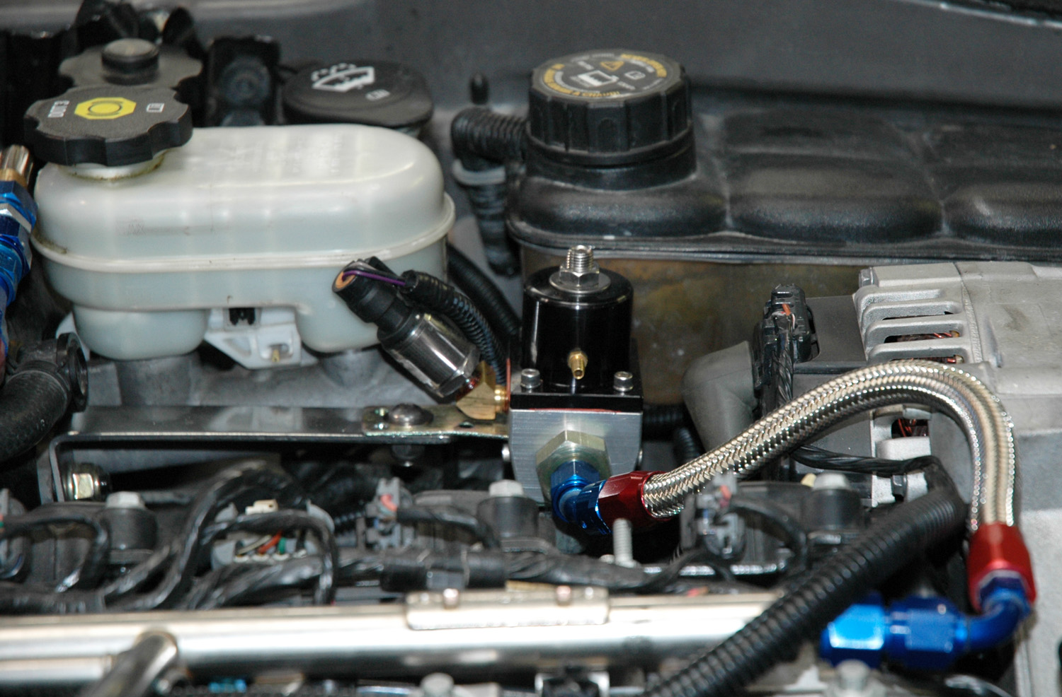
(BRACKET MOUNTED ON BRAKE BOOSTER)

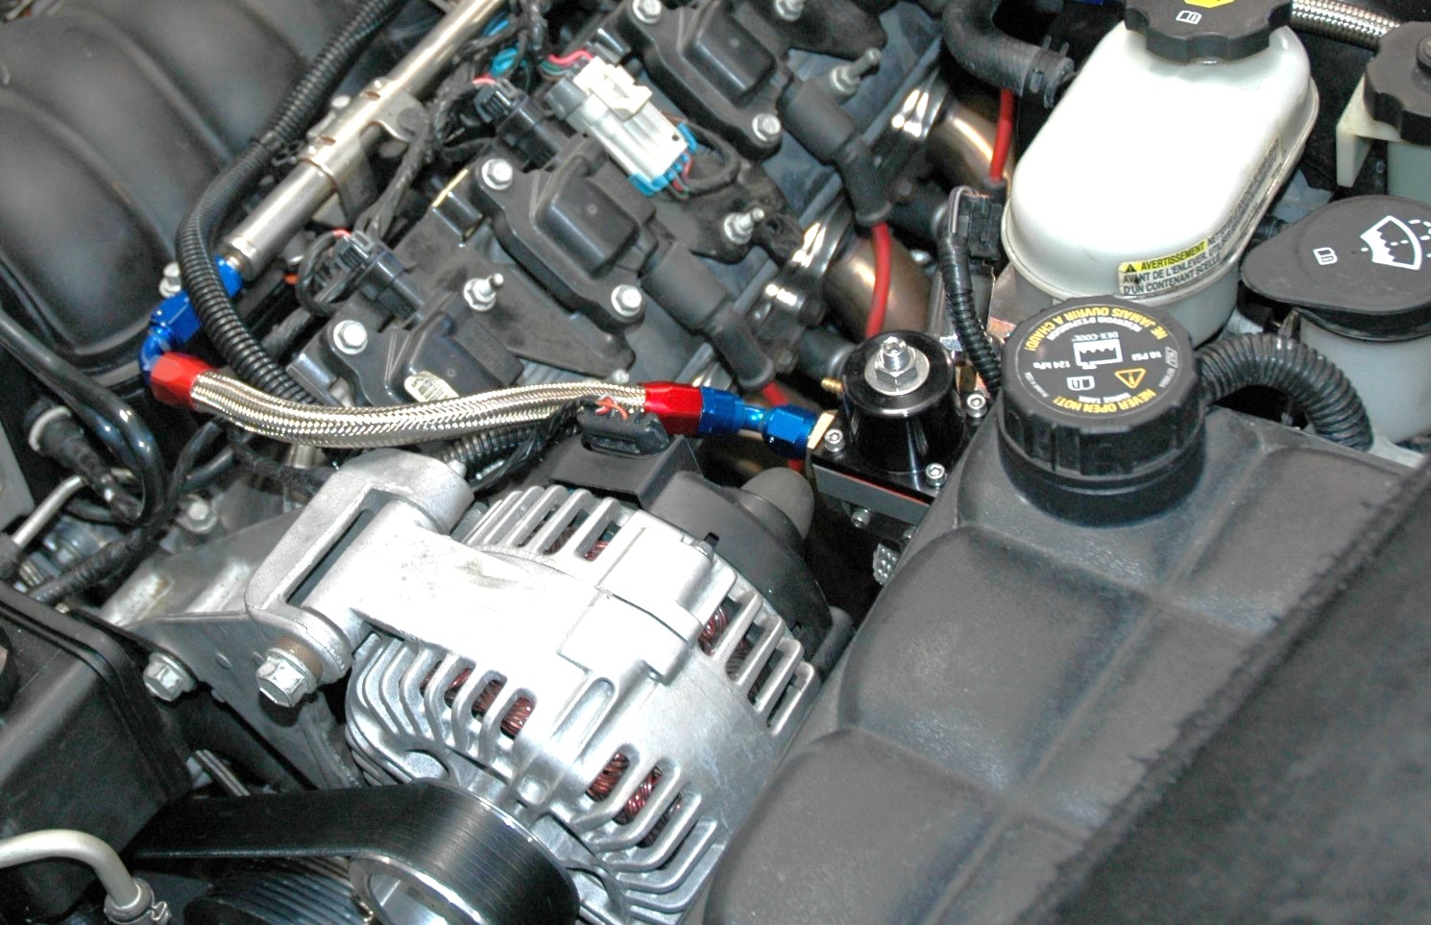
(RETURN LINE ATTACHED TO FUEL RAIL AND REGULATOR)

2.6 The long return line will be routed down the tunnel, above the tunnel plate, back to the tank. The end with 45-degree fitting goes in the front of the car and attaches to the fitting on the bottom of the regulator. The straight end attaches to a 90-degree fitting that is threaded into the tank in the same manner as the feed line. Make sure the line is secured away from the exhaust and any moving parts.

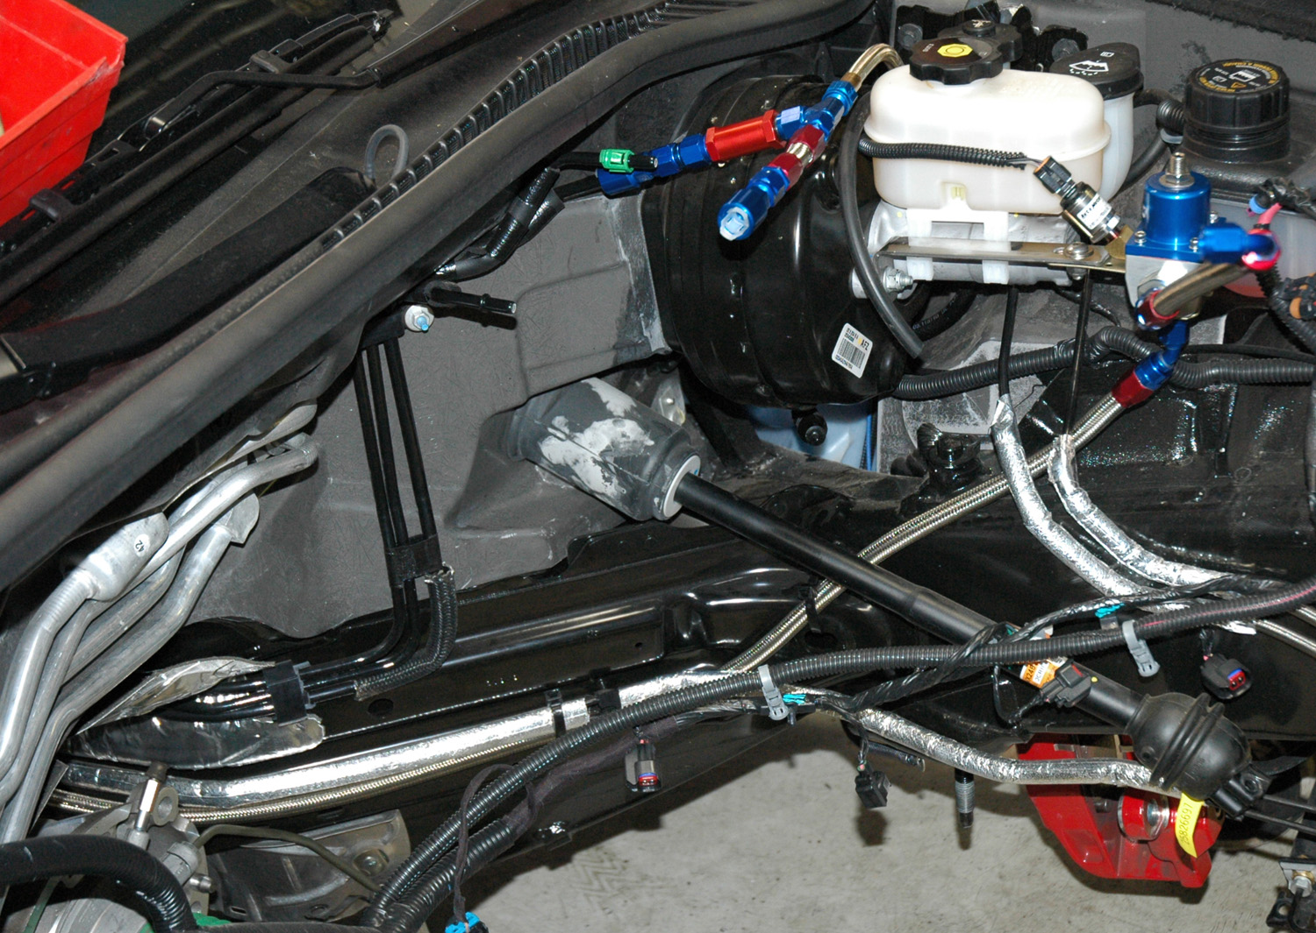
(EXAMPLE OF RETURN LINE SECURED OUT OF THE WAY)

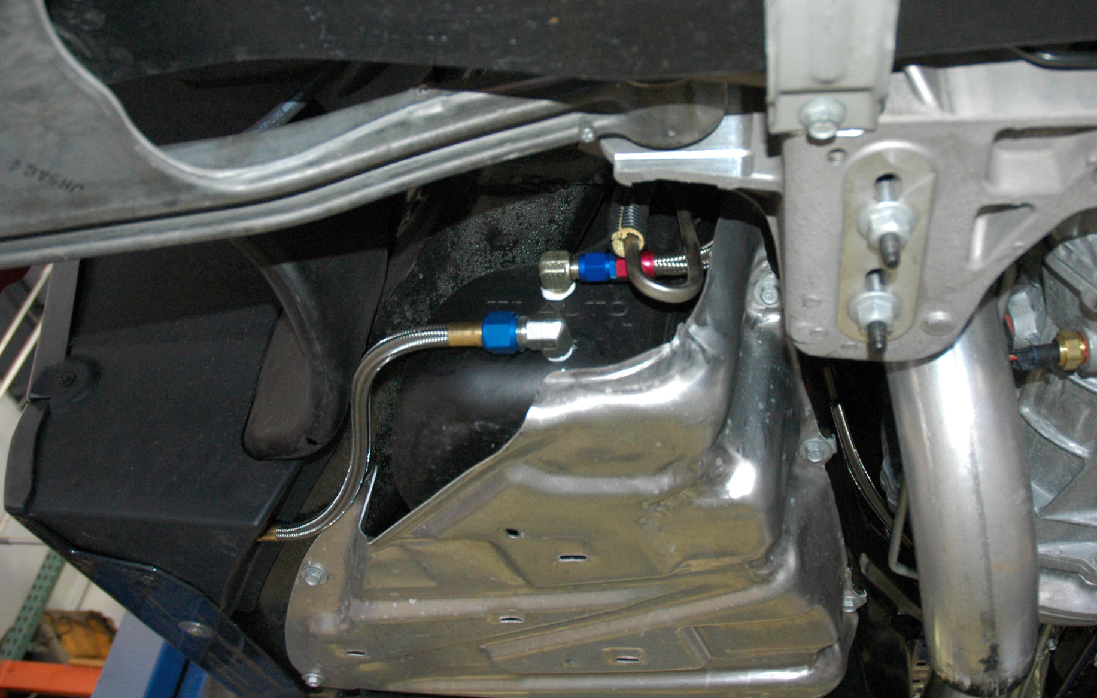
(FEED AND RETURN LINES ATTACHED TO FUEL TANK)

- ELECTRICAL
  - Mount the relay in a convenient place under the hood. The long red wire should already be attached to the fuel pump. The wire with the 3/8” eyelet is attached directly to the alternator positive terminal. The other wire is attached to a Hobbs switch. This switch is plugged into the vacuum line running from the brake booster hose. Find a suitable ground (NOT the valve cover or coil bracket!) and attach the wire from the vacuum switch. The relay will be grounded when the switch sees about 3-4 # of boost and will fire the pump. You can jump the switch to test the pump and connections and to set your base fuel pressure. Make sure everything is routed where it can’t chafe, touch the hot terminal on the alternator, or run too close to the exhaust.

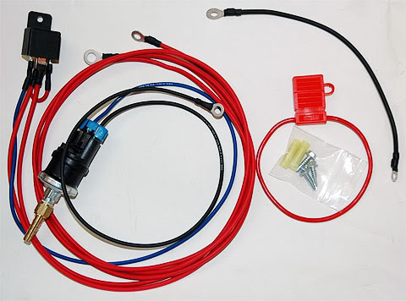
(WIRING HARNESS WITH HOBBS SWITCH)

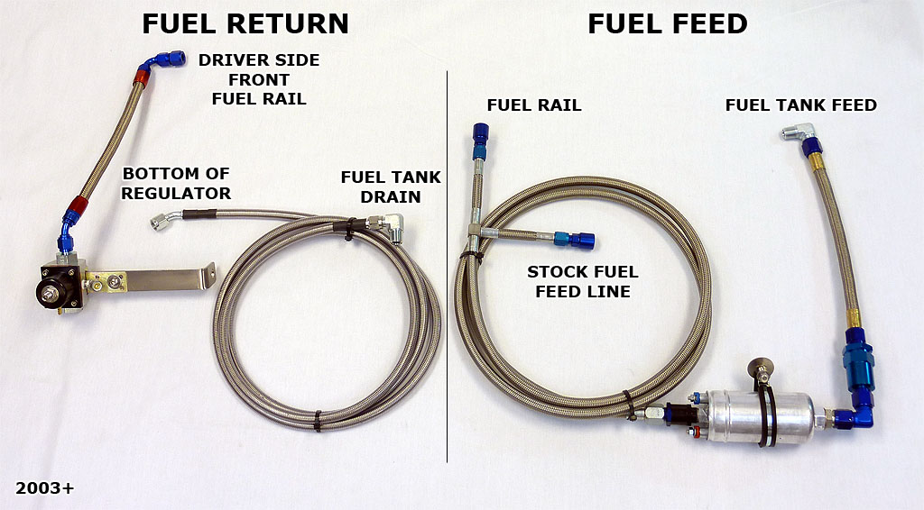
(OVERALL REFERENCE)

A & A Corvette Performance, Ltd.
477-A Lambert Street
Oxnard, CA 93036
Local: (805) 278-4107
Toll Free: (888) VETTEPRO
www.aacorvette.com

