NEW C5-C6 SECONDARY DRIVE- V3 INSTRUCTIONS 6/26

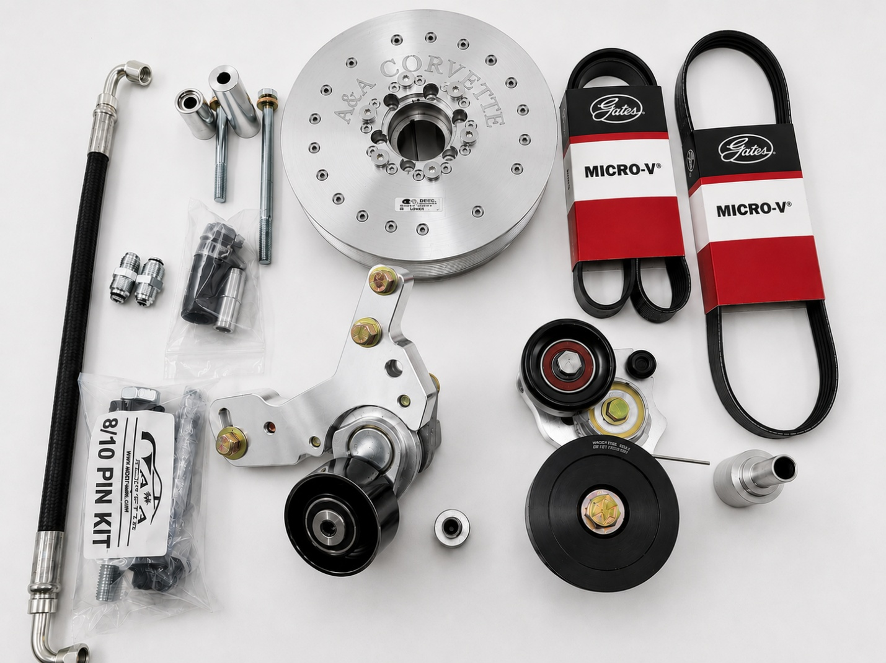

The new Secondary Drive V3 is easier to install, has a spring tensioner for each belt, and offers unparalleled belt grip. We changed the transfer pulley diameter to 3 ½” to slow the bearing speed and offer more belt surface area. We have also contracted with Griptec to process and anodize our transfer pulley to further enhance belt grip.
The A&A Secondary Drive is also unique in that it does NOT drive the accessories via the air conditioning belt. The Secondary Drive shaft pulley is driven by its own dedicated belt. This allows full belt wrap around the crankshaft pulley as well as the accessory shaft pulley and the ability to tension this belt separately. This eliminates accessory belt slip that plagues other systems. Our system utilizes a spring tensioner on the alternator / power steering belt and on the transfer shaft belt, which allows proper belt wrap and tension.
This system MUST be used with our INCLUDED proprietary balancer. A stock balancer or a standard 8 rib balancer from ATI or Innovators West will not work.
The kit comes complete with our proprietary SFI spec balancer (10% overdrive), all belts, hoses, pulleys, tensioners, and brackets needed.
Using our Secondary Drive allows the use of a much shorter belt to drive the supercharger which eliminates stretch and belt whip. This is the ultimate belt drive system for street driven C5 and C6 Corvettes with air conditioning as well as dedicated race cars without air conditioning.

REPLACE THE STOCK BALANCER
Replacing the balancer will require removal of the steering rack to gain access. The lower Secondary Drive section and balancer will be easier to work on with the radiator removed. Remove the original balancer with an appropriate puller. If you have a forged crank, with a key, align the key with the slot in the balancer and press the balancer on with an appropriate installer. Put a little anti-seize on the inside of the balancer hub to stop any galling. (these tools are often available for rent to your local auto parts store)
The balancer will not be flush with the end of the crankshaft. It will be about ¾” out. This is normal. If you don’t have a key in your crankshaft, you will have to pin the balancer to the crank.
Bolt the drill guide in place with the provided bolt. Use the guide to drill a ¼” hole, being careful to drill straight in. The aim is to make half the hole in the balancer and half in the crankshaft. You want the end of the pin to be just below the level of the balancer hub. Double check the depth of the hole with a caliper or even a small screwdriver. It’s imperative that the pin not sit higher than the lip of the balancer. If it does, it will dig into the flange on the bolt, and the bolt won’t seat properly
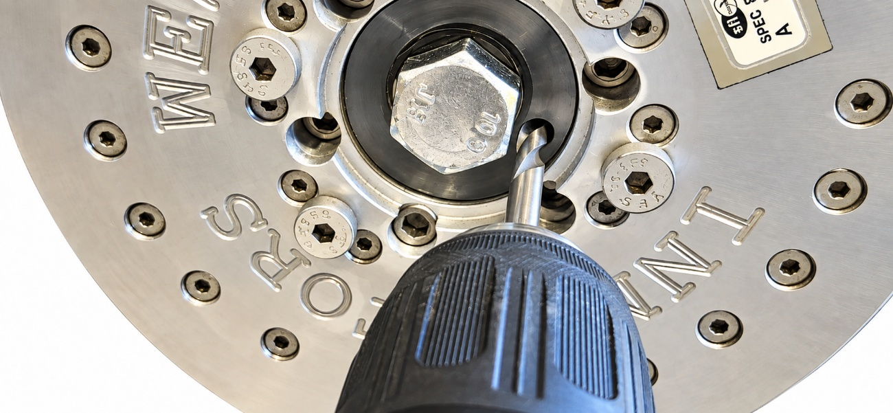
DRILL GUIDE IN PLACE

Remove the guide and bolt. Replace it with the provided OE bolt and washer. Tighten it to spec, with a small amount of Loctite on it. (Hit it with an impact gun until it stops moving)
Once the balancer is installed, don’t forget to install the AC belt.

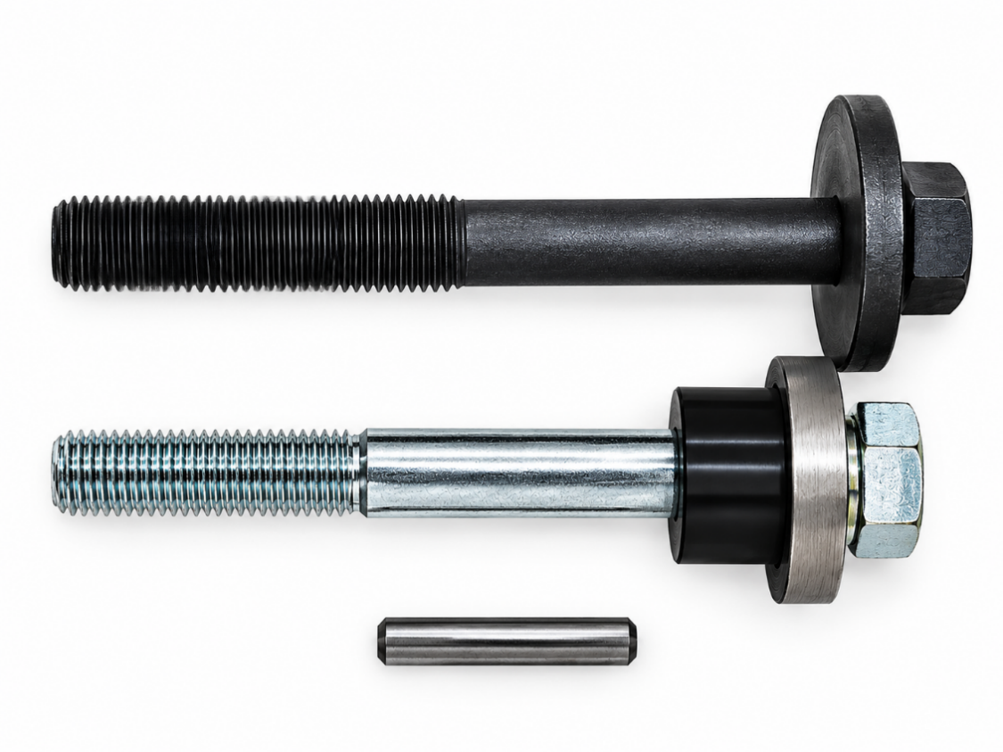
8 and 10 RIB PIN KIT

REPLACE OR MODIFY THE EXISTING ALTERNATOR BRACKET
DISCONNECT THE BATTERY, then remove the alternator and power steering pump. The plastic pulley will need to be removed to access the pump bolts on C5 only and allow installation of our custom fitting and hose. You can remove the pump and reservoir together and pour the fluid into a clean container. Remove the reservoir mounting bracket.
If you have the plastic C5 pulley, we recommend replacing it with a slotted steel C6 pulley which has access slots for the pump bolts. Many times, you will not be able to remove the plastic pulley without breaking it anyway, so be prepared.
Modify the stock alternator bracket by cutting off the section indicated by the black line. A bandsaw works best but any sort of saw or cutting tool will do. We can also supply a NEW bracket that has been properly modified with the kit, as well as the slotted steel C6 pulley. We keep these in stock.
Bolt the modified alternator bracket back in its original position. The factory bolt holes have some “fudge room” built in. One hole is even oblong. Once in place, you’ll want to pry upward on the bracket, before tightening it down, to give you more clearance between the P/S hose fitting and the transfer pulley. (test fit the lower Secondary Drive bracket to make sure you’ve aken enough off the alternator bracket)
Mount the alternator in the bracket. Install the upper alternator bolt loosely for now. You are only using the upper bolt as a guide to make sure the alternator is lined up with the upper hole. Tighten the lower bolt so the alternator doesn’t move around, then remove the upper bolt.
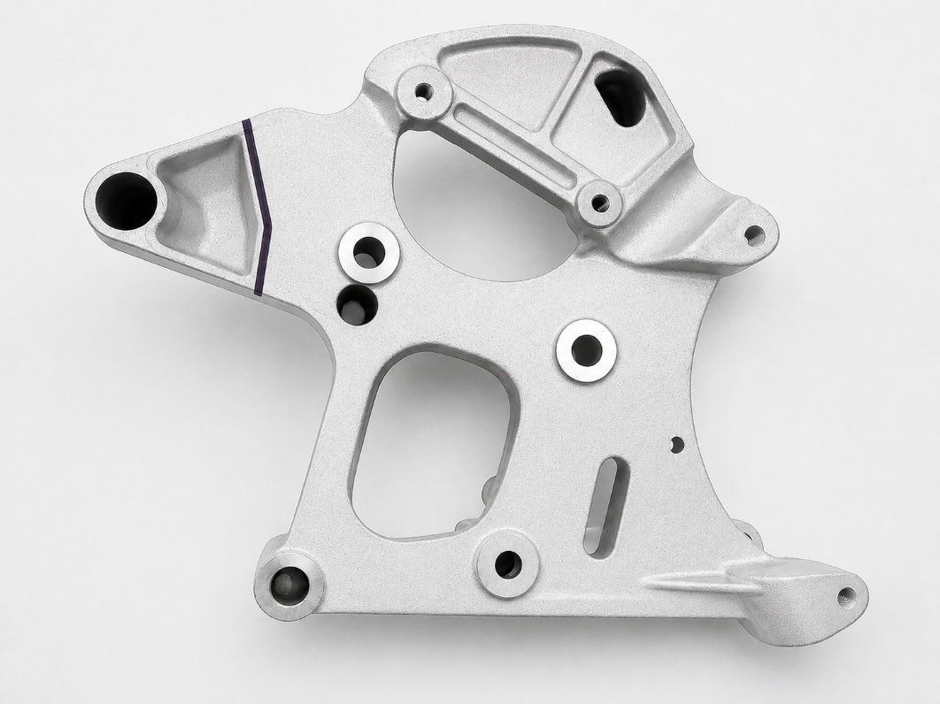

ALTERNATOR BRACKET MODIFICATION

Install our custom fittings in the power steering pump and steering rack. There are two fittings. The 16MM threaded fitting goes in the pump and the 18MM threaded one goes in the steering rack closest to the frame. The 90-degree end of the hose with the beveled fitting goes on the pump. The corner is beveled to clear the pulley. Angle the hose slightly towards the engine. Install the power steering pulley and check for clearance between the pulley and hose fitting. Install the pump assembly back in the bracket. (you can only do it this way with the slotted C6 pulley) Install the hose on the steering rack by routing it under from the back and up to the pump fitting.
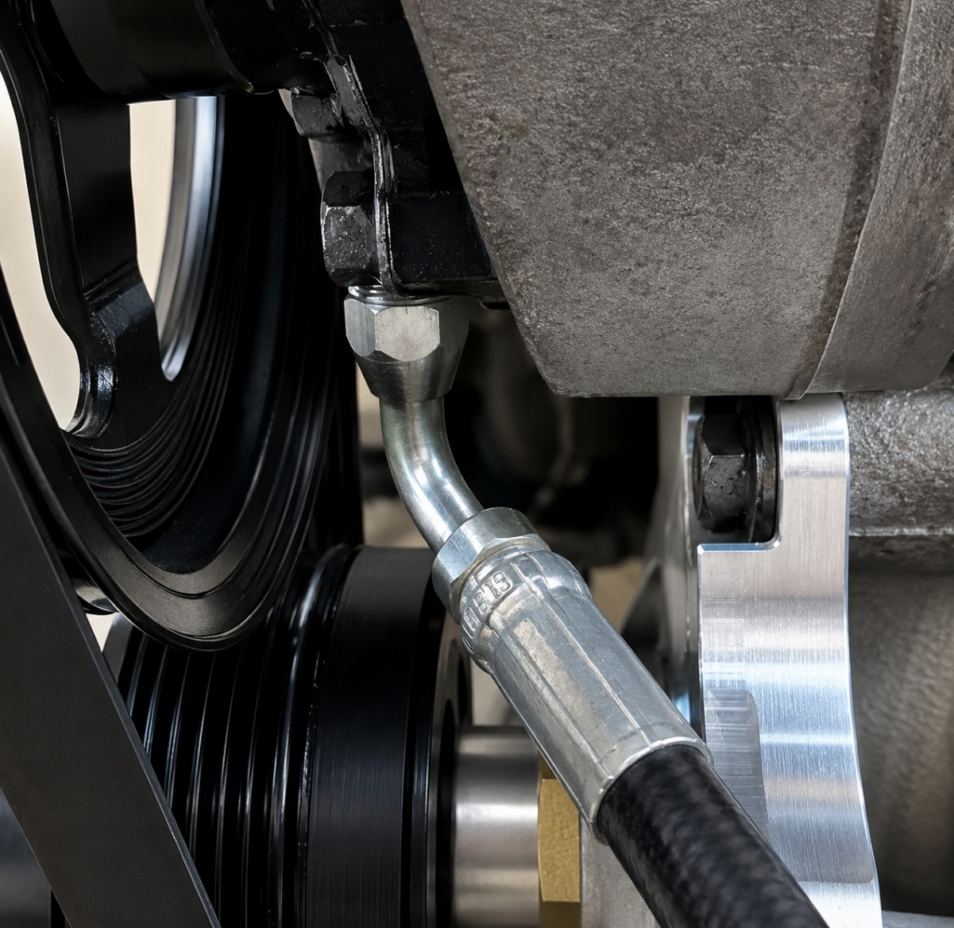
ANGLE THE HOSE SLIGHTLY TOWARDS THE ENGINE
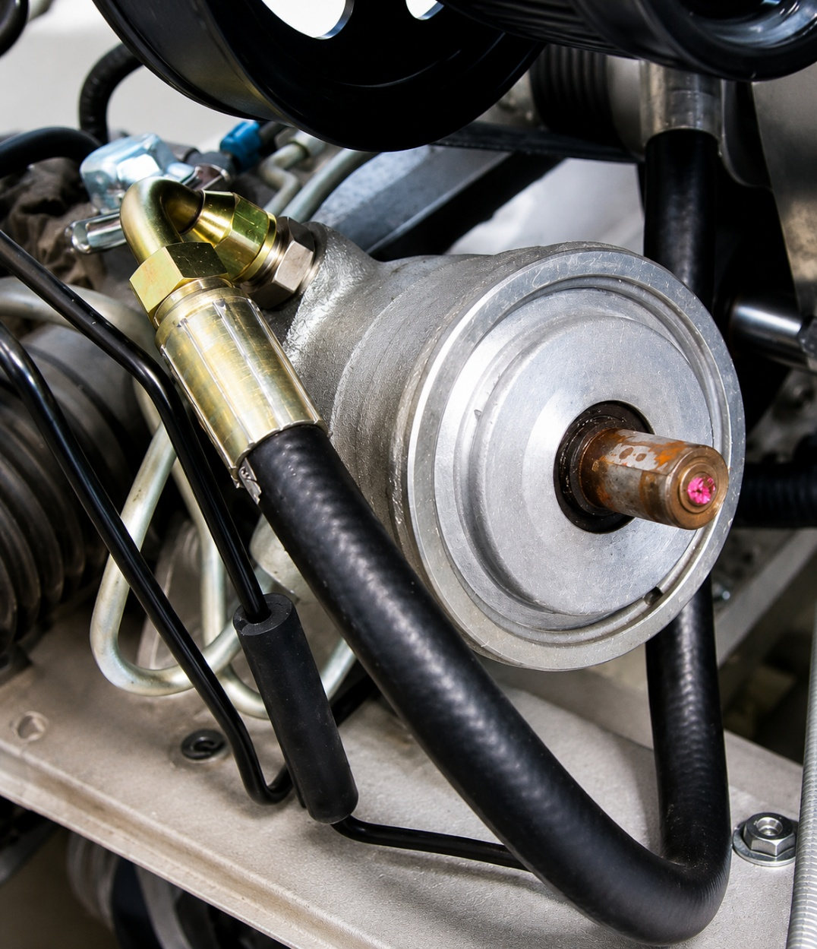
HOSE GOES UNDER THE GEAR BOX

INSTALL THE LOWER TENSIONER AND TRANSFER ASSEMBLY
We send the lower tensioner and transfer pulley as an assembly, so the installer gets an idea of how it goes together. Temporarily remove the transfer pulley and tensioner from the lower tensioner plate. Bolt the plate to the block using the 3 existing bolt holes. (Some iron blocks are missing one of the holes. We’ve had no reported issues using only two bolts in the mounting plate) On dry sump cars, move the oil lines out of the way.
YOU MAY FIND THIS VIDEO HELPFUL

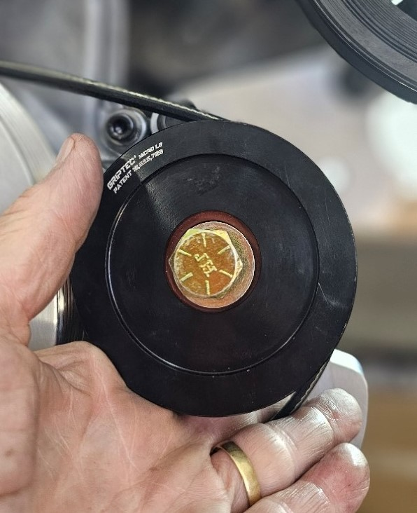
Slip the 4-rib belt over the balancer, making sure it is properly seated in the 4 foward grooves. Slip the transfer pulley assembly through the loop in the belt and seat it in the 4-groove section of the transfer pulley. Slide the transfer pulley assembly over to the threaded hole and put the bolt in by hand. Keep the pulley spacer close to the bracket so the bolt is not protruding out through the spacer. Some Gates belts are slightly shorter than others with the same part number. If you are having trouble getting the pulley bolt started, loosen the bracket bolts so you can tilt the bracket towards the balancer. (I stuck a bolt behind it in the picture; to hold the bracket forward) You should then be able to slide the pulley assembly over the ½” hole and get the bolt started. Tighten the three 10mm bracket bolts to 35#. Tighten the ½”pulley bolt to 40#.

TRANSFER PULLEY THROUGH THE LOOP IN THE BELT
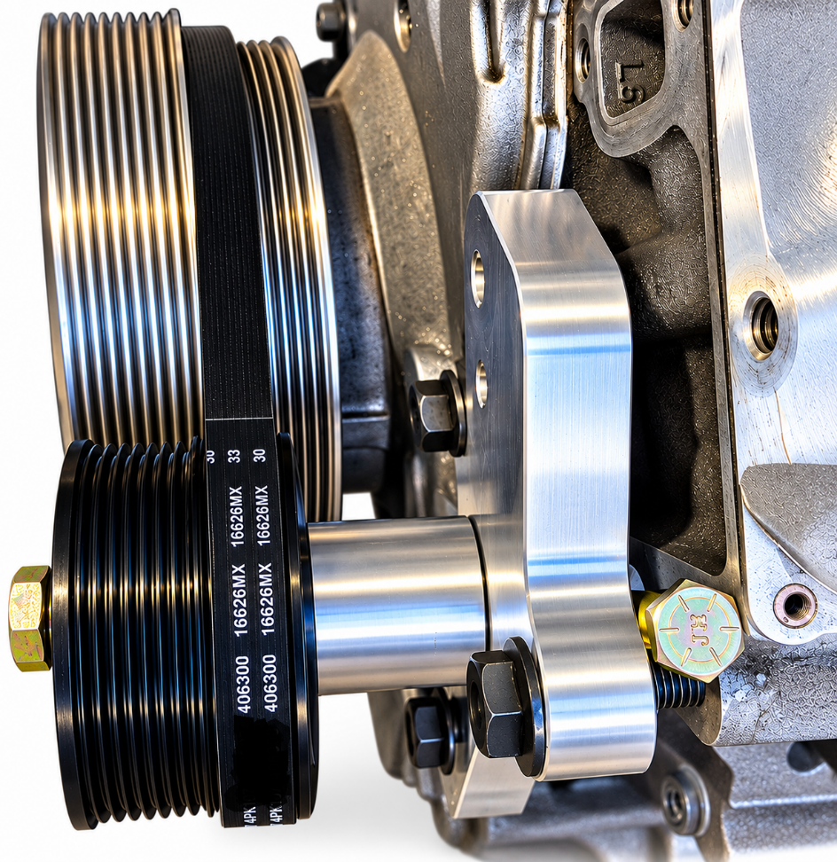
BRACKET TILTED- MAKES IT EASIER TO SLIDE THE PULLEY ASSEMBLY OVER THE THREADED HOLE

Move the tensioner over the 3/8” hole and start the bolt by hand. It’s best to start the bolt while the tensioner is away from the bracket, meaning it is on the bolt but pulled out toward the head of the bolt. Once the bolt is threaded part way, move the tensioner to align the guide pin hole and tighten. You can pull the lock pin from the tensioner now.
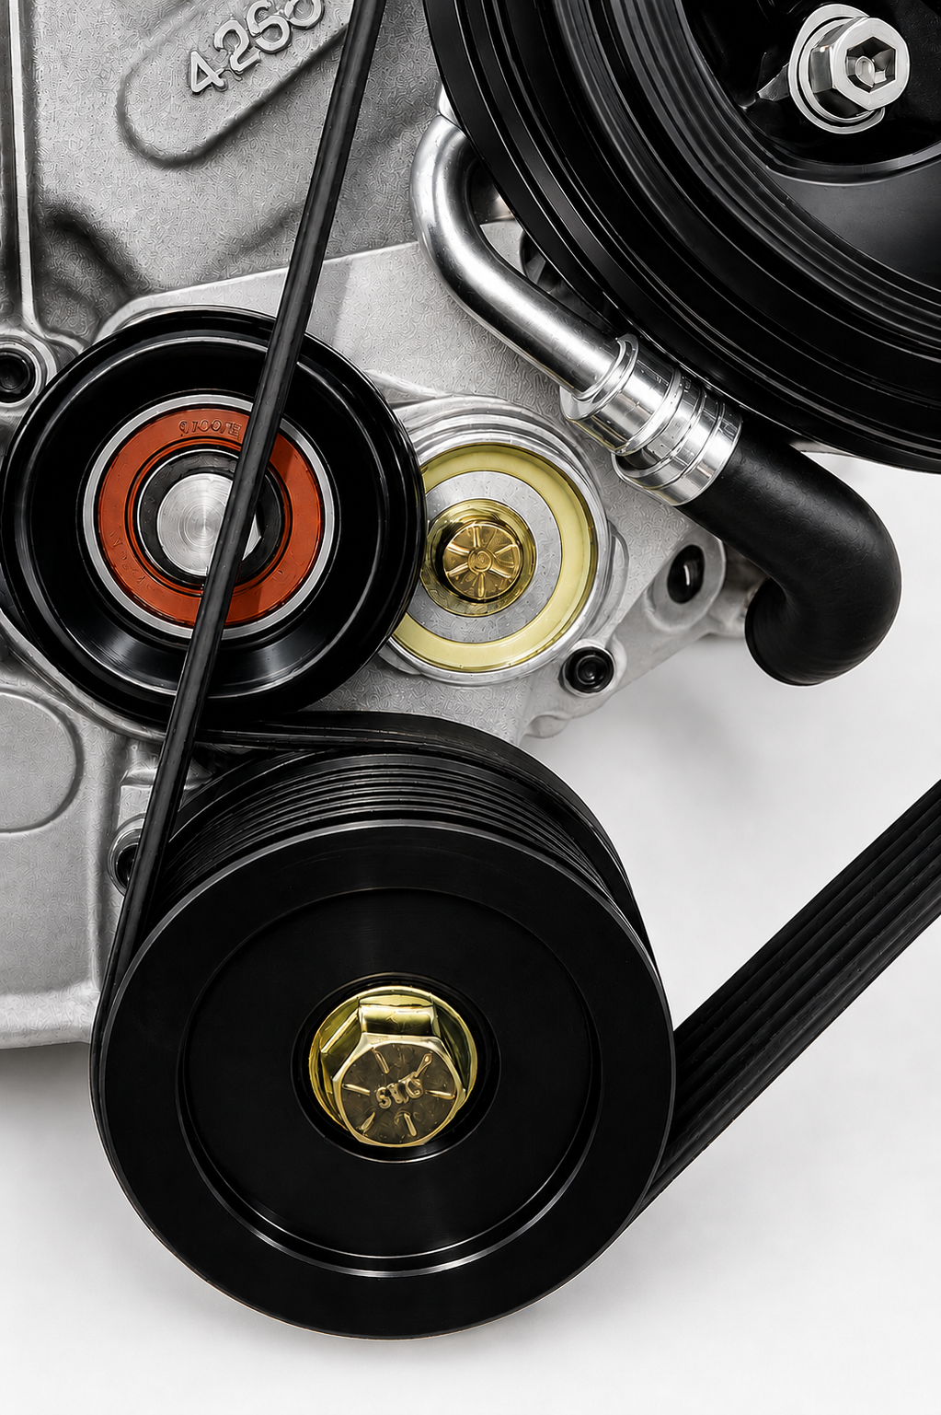
BOTTOM SECTION COMPLETED

It’s been reported that SOME C5 water pumps have a clearance issue with the tensioner pulley in the full slack position. The pump will need to be relieved as shown.
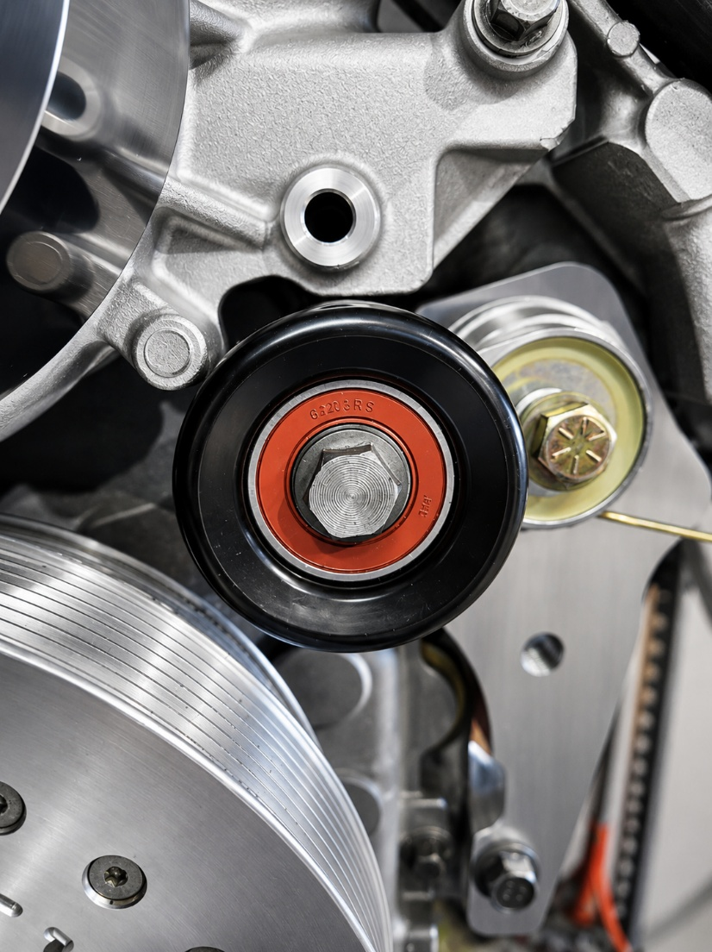
INTERFERENCE ON SOME C5 WATER PUMPS
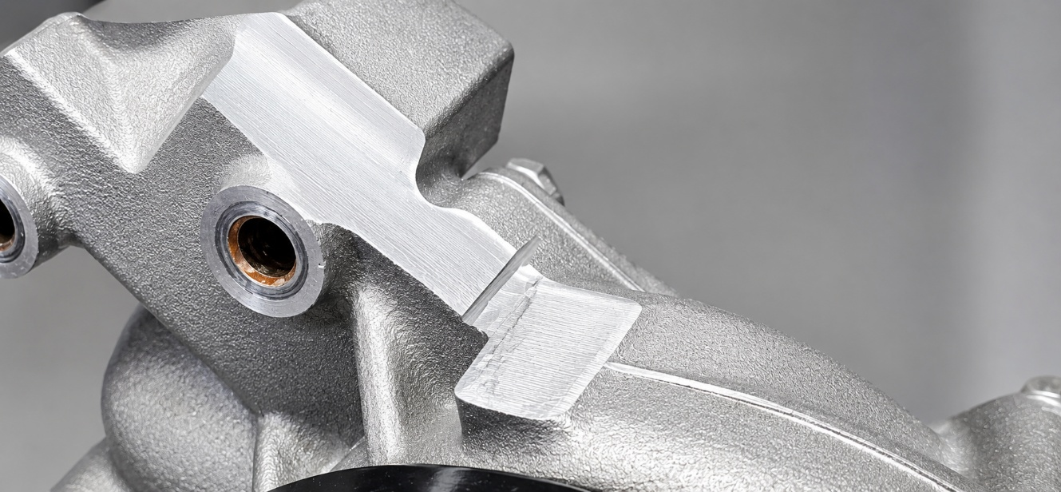
C5 WATER PUMP MODIFICATION (some models only)

INSTALLING THE ALTERNATOR BELT
The alternator belt will NOT go over all 3 pulleys at once. You MUST put it around the transfer pulley, the alternator pulley and ONE side of the power steering pulley. The last step is to pop the belt over the edge of the power steering pulley. See the picture below for clarification. If one side of the pulley doesn’t work, try the other side. It’s very tight. Some pulleys have a larger lip than others. Gates belts also have a slight variance in lengths. It’s “possible” you may have to remove both alternator bolts, so it drops down in the bracket a bit, and then realign it after the belt is on.
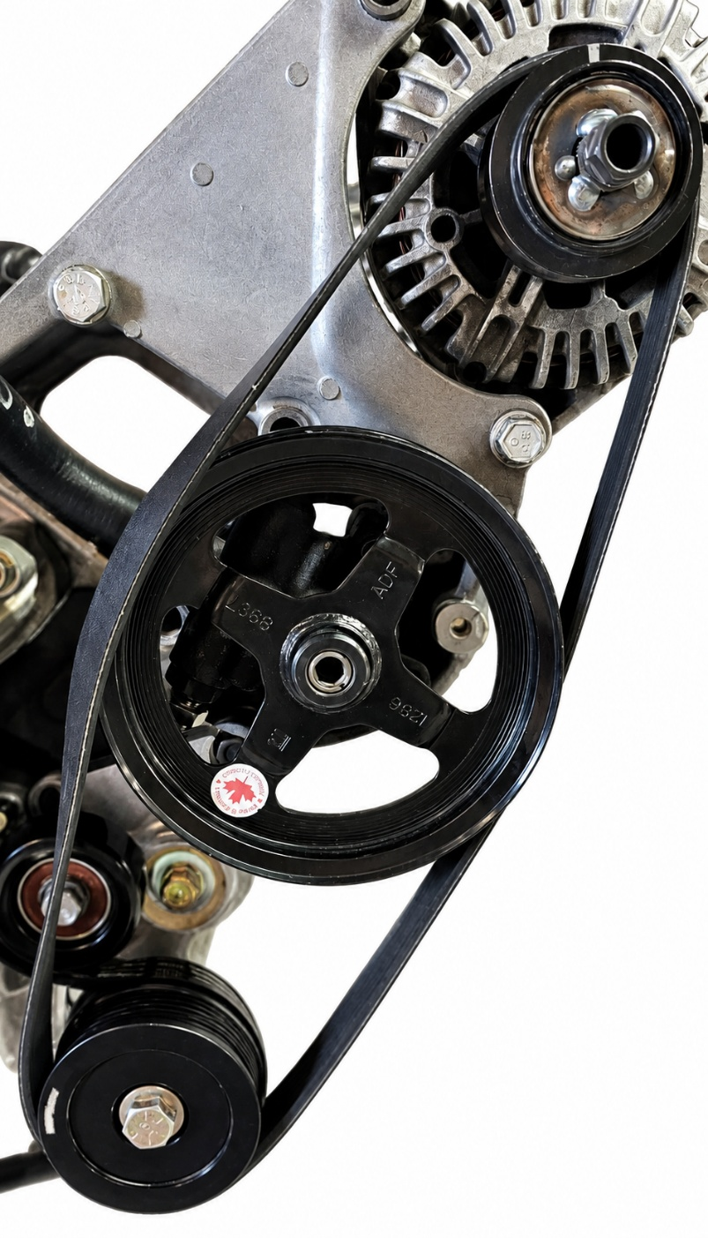
POP THE BELT OVER THE POWER STEERING PULLEY LAST
You’re pretty much done on the lower side, so you can reinstall the steering rack now. We have left it out until now to give you more room to work.

INSTALLING THE UPPER TENSIONER BRACKET
Insert one of the 10MM X 150MM (6”) bolts through the upper tensioner bracket along with the 1” X 2.16” spacer. This bolt will go through the alternator bracket into the cylinder head. Leave this bolt slightly loose (with approximately 1/8” slack in it). Swing the tensioner bracket up and away from the belt. You’ll see another spacer that measures 1” X 1.14” with a recess machined in one end. The recess goes towards the motor and will fit over the bushing in the alternator bracket. The slack left in the first bolt will allow room for the spacer with the recess to clear the bushing in the alternator bracket as you swing it down. Put the remaining 10MM bolt through the slot in the bracket and the spacer. Insert a 3/8” ratchet in the square hole and rotate the tensioner bracket down until you are able to insert the long bolt through the upper alternator hole. As you swing the bracket down, the tensioner will collapse into place. Tighten both bolts now. There is an adjustment slot in the bracket, but in the middle generally works just fine.
Note how the upper spacer is oriented with the recess towards the alternator. The recess fits over the bushing that is pressed into the alternator bracket.
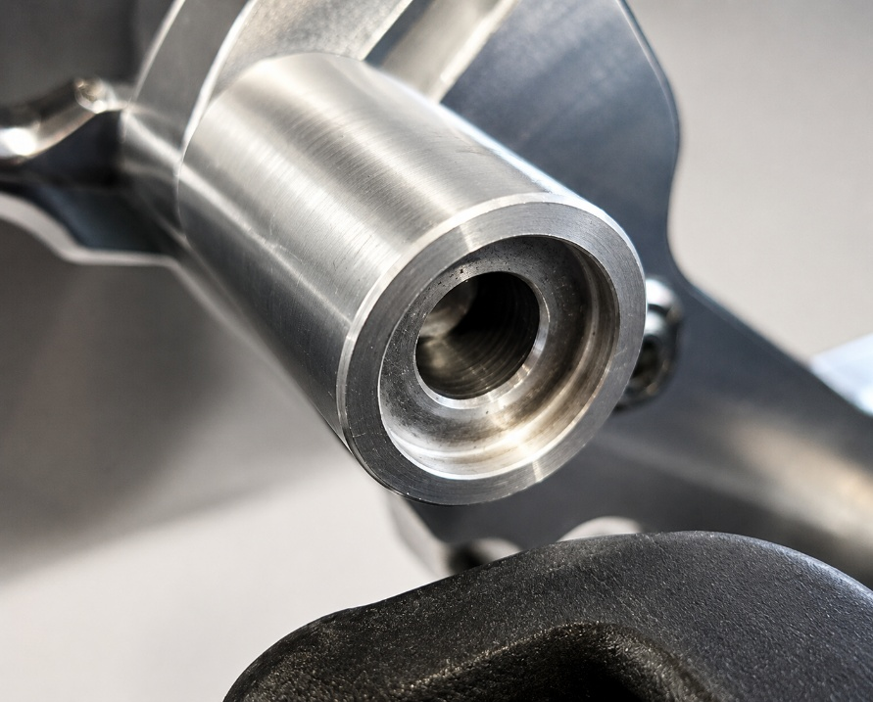
UPPER SPACER ORIENTATION
Also supplied is a reservoir relocation kit. Bolt the supplied reservoir bracket onto the back of the tensioner bracket and install the reservoir on the bracket. Install the barb fitting and hose extension in the reservoir hose and connect it to the reservoir. Fill with fluid and check for leaks.
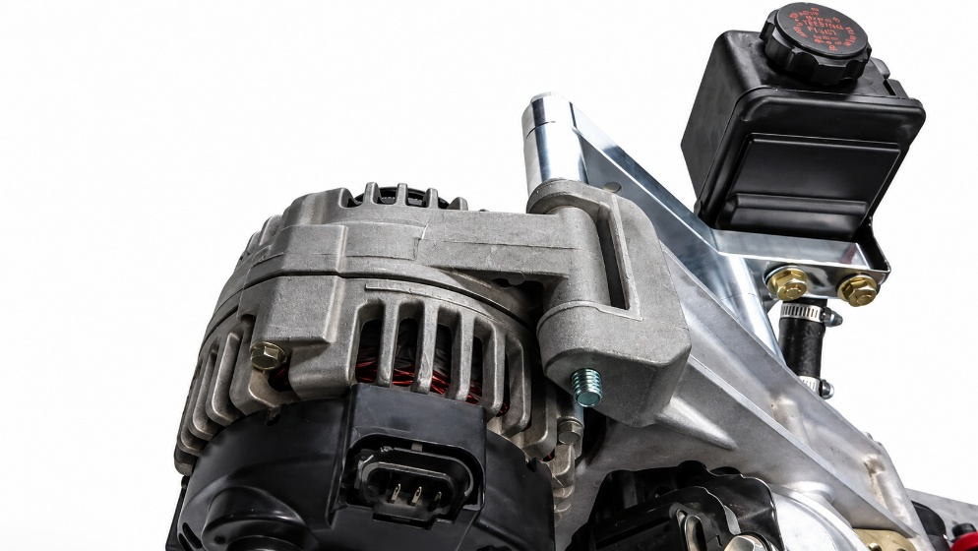

RESERVOIR MOUNTED TO TENSIONER BRACKET

